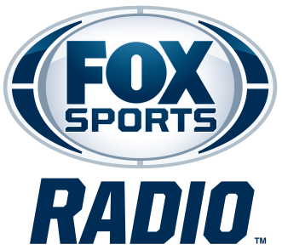

### KELVIN WASHINGTON

**BIOGRAPHY**

Veteran sports media personality Kelvin Washington is co-host of FOX Sports Radio’s *The Odd Couple*. Joined by co-host Rob Parker, the program features dynamic discussion and outspoken opinions as the duo covers the biggest stories and headlines in sports. The Odd Couple with Rob Parker and Kelvin Washington broadcasts Monday through Friday from 7 to 10 p.m. ET on 350 radio stations nationwide, and can also be heard on FOX Sports Radio’s [channel](http://www.iheart.com/live/fox-sports-radio-4732/?pname=13133&campid=play_bar&cid=index.html) on iHeartRadio and FOXSportsRadio.com.

An Emmy Award-winning Spectrum News 1 SoCal Host/Anchor, Washington has been with the network since its launch in 2018, covering local issues that impact Southern Californians. In August 2024, he took over as host of *Your Morning on Spectrum News 1*.

He is also a frequent contributor on Spectrum News 1's *LA Times Today* and is one of the hosts of the pre- and post-game shows for the Dodgers on SportsNet LA.

A Golden Mike award recipient in 2021, Washington has extensive experience hosting special documentaries and original programming, including *The Envelope: Emmy Roundtables* and Spectrum News 1's Emmy-nominated show, *50 Years of Hip Hop: From the Westside*.

Over the course of his career, Washington has interviewed many sports personalities and athletes, including Clayton Kershaw, Magic Johnson, Kareem Abdul Jabbar and Grant Hill.

Washington joined ESPNLA 710 in 2014, and the station debuted *Kelvin and Travis* a new local morning drive program in 2015. He later co-hosted *Marcellus and Kelvin* followed by *Afternoons with Marcellus, Kelvin and E.D.* in afternoons. Previously, Washington served as an on-air personality for Radio Disney on Sirius XM and 99.1 KGGI, an iHeartMedia station.

Washington also served as co-host of NBC’s *Spartan: Ultimate Team Challenge*, a series where top athletes competed on an obstacle course for a cash prize.

Fans can follow Washington on [Twitter](https://twitter.com/Kdubblive) and [Instagram](https://www.instagram.com/kdubblive/)*.*

# # #